Civil War: North vs. South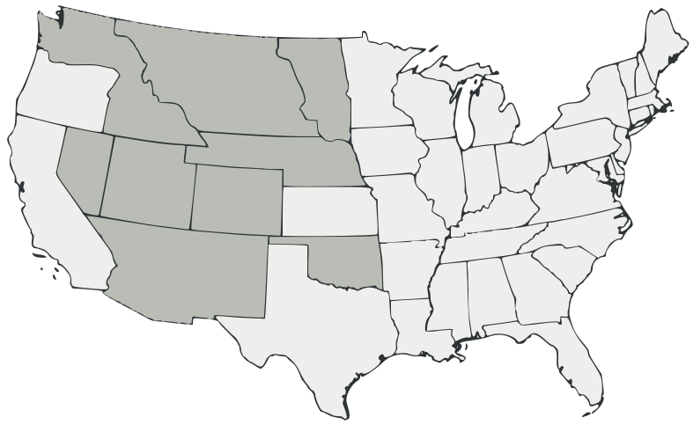
Map Key
Label each state on this map. Color code each state according to the map key that you create on the left.
Union States
Confederate States – Left prior to Ft. Sumter
Confederate States – Left after Ft. Sumter
Border States (part of Union)
Territories
West Virginia (separated from VA in 1861 and joined the Union in 1863)

